- 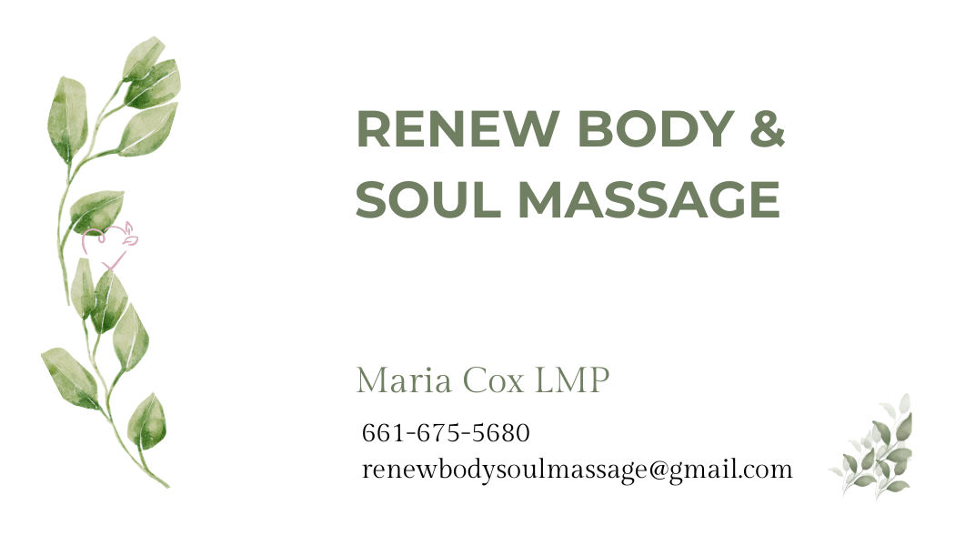While often recognized for its profound physical and mental health benefits, the practice of massage therapy also offers significant avenues for spiritual well-being. Beyond alleviating muscle tension and reducing stress, therapeutic massage can foster a deeper connection between mind and body, facilitating introspection and promoting a sense of inner peace.
- Renew Body & Soul Massage additionally offers a safe place where each person is seen, heard and valued.

Massage therapy serves as a powerful conduit for integrating the mind, body, and spirit. By encouraging relaxation and heightening bodily awareness, it creates a receptive state for spiritual reflection and self-discovery. The gentle, intentional touch central to massage helps dissolve energetic blockages, fostering the free flow of vital life energy, or “chi,” which many spiritual traditions recognize as essential for balance and vitality. This harmonious alignment nurtures emotional release, clarity of thought, and a deeper sense of presence. Ultimately, massage acts as a bridge that unites physical sensations with mental calmness and spiritual openness, laying the groundwork for holistic well-being and personal transformation.

